

A PROJECT REPORT ON

HAZARDOUS AREA MONITORING FOR INDUSTRIAL PLANT POWERED BYIoT

**Domain:** Internet of things.

**Team ID:** PNT2022TMID15007

**College Name: R.M.D** Engineering College

**Department of Electronics and Communication Engineering**

Nithyasri D.C-111519106107

Naveena R-111519106101

Swathi B-111519106157

Vaishnavi S-111519106165

1

**TABLEOFCONTENTS**

1. INTRODUCTION...................................................................................................................3a. Project Overview.....................................................................................................3b. Purpose....................................................................................................................4

2. LITERATURE SURVEY............................................................................................................4a. Existing Solutions.....................................................................................................4b. References...............................................................................................................5c. Problem Statement Definition.................................................................................5

3. IDEATION & PROPOSED SOLUTION.....................................................................................6a. Empathy Map Canvas..............................................................................................6b. Ideation & Brainstorming........................................................................................6c. Proposed Solution...................................................................................................7d. Problem Solution fit.................................................................................................7

4. REQUIREMENT ANALYSIS....................................................................................................8a. Functional requirements.........................................................................................8b. Non-Functional requirements.................................................................................9

5. PROJECT DESIGN.................................................................................................................9a. Data Flow Diagrams...............................................................................................10b. Solution & Technical Architecture.........................................................................11c. User Stories...........................................................................................................12

6. PROJECT PLANNING & SCHEDULING.................................................................................13a. Sprint Planning & Estimation.................................................................................13b. Sprint Delivery Schedule........................................................................................14c. Reports from JIRA..................................................................................................15

7. CODING & SOLUTION........................................................................................................16

8. TESTING.............................................................................................................................17a. Test Cases..............................................................................................................17b. User Acceptance Testing.......................................................................................18

9. RESULTS.............................................................................................................................18a. Performance Metrics.............................................................................................18

10. ADVANTAGES & DISADVANTAGES....................................................................................19

11. CONCLUSION.....................................................................................................................19

12. FUTURE SCOPE..................................................................................................................19

13. APPENDIX..........................................................................................................................20a. Source code...........................................................................................................20b. Video demonstration links....................................................................................21

2

**1.INTRODUCTION**

**a. Project Overview**

Wounds, characteristic impact, and materials mischief, these types of accidents maybe a direct result of the mechanical method, some essentialness related issues or transportworks out. They are generally associated with either enormous inventory of ignitable, flimsy or

very open gases or of standard risky manufactured substances in method organization or smallermeasure of uncommonly hurtful. The causes arise out of unsafe situational and climaticconditions and assortments. These may fuse over the high temperature and humidity. It

prompts different going of people and various misfortunes.

Reaction of smooth extreme hurting greater exposure. These smart industries will beadditionally evolved and modified as differentiated and existing ones and able to monitor just ascontrolling of different industrial application. IoT is used for transmission and gathering ofinformation. These systems are used to screen mechanical application by realizing industrystandard shows using IoT.

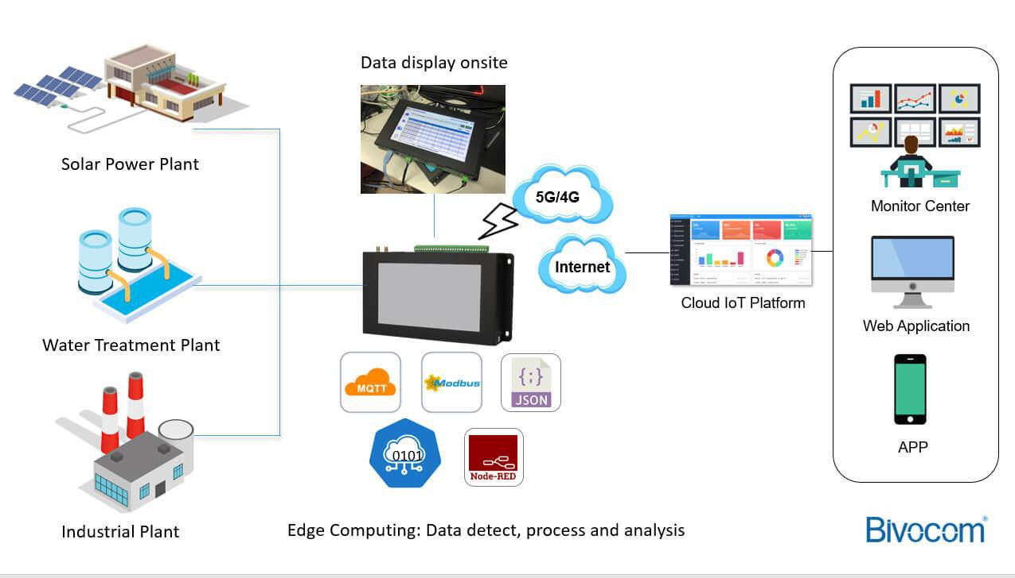

**Fig: IoT based monitoring system environment**

3

**b. Purpose**

Through this we can monitor the temperature and humidity parameters of the hazardousarea in industrial plants. Every person working in those areas will be given a smart device formonitoring the random temperature and humidity values. We develop the web application forviewing the temperature and humidity data using Node-RED and if the temperature is higher than

60, then the admin of the industrial plant will receive the high temperature alert message or elseadmin will receive the temperature reset message through email using Application programminginterface (API) then the admin will take the necessary precautions if required.

**2.LITERATURE SURVEY**

**a. Existing Solutions**

Research in [1] proposed an **IoT-based smart agriculture monitoring system**. Their workfocused on devices and tools to manage and monitor temperature, humidity, soil moisture,atmospheric moisture, and intruders by using a wireless sensor network (WSN) system. Themonitoring system is performed by two methods which are via hardware by using the LCD andandroid application. Any parameters exceed the threshold value, an alert system will send amessage to the user via GSM.

According to [2], **Hazardous area safety monitoring system based on wireless sensornetwork** can effectively and accurately reflect dynamic situation monitored with help of **computerbased virtual instrumentation technique**. Agent based wireless local positioning system withZigbee technology is implemented. A cost effective Zigbee based wireless safety monitoringsystem with early-warning intelligence on temperature, radiation, flammable and poisonous gasand fire and smoke in hazardous areas. With virtual instrumentation software, the safety systemis obtained.

**Android user via C2DM Service** [3] presents a WSN prototype for remote roomtemperature monitoring, which can be used for fire operations, via an android platform. Theproposed system provides an Android user interface for registered users to access the currenttemperature and a flash/beep message in case of fire.

Authors in [4] use an embedded controlling device (Raspberry Pi), which gathers andprocesses the data generated by sensors like temperature sensors and gas detectors. A cloudplatform is used to visualize and analyse the generated and also thereby enabling us to performreal time tracking and possibly implement a warning system, say notifications through the cloudor an audible alarm.

4

Research in [5], proposed an **IoT Based Industrial Parameter Monitoring System**. Theyintroduced an Arduino module that operates with solar energy and uses battery charger circuit, itis operating nighttime also. This module is interfaced with different sensors. Data acquired fromeach sensor is collected in the Arduino module and is displayed in (16x2 LCD) which is used astheir output module. The in-built analog to digital (ADC) converter is used to measure the voltageand current. The water pump releases when there is fire. The voice module gives voice output ofvarious requirements. The LED glows when there is some gas leak or some problem.

According to the existing solutions, users have limited access to the monitoring system tomonitor parameters of industrial hazardous area at anytime and anywhere. Most monitoringsystems only provide fault alarms without indicating the type of parameters including the valueof the parameters.

**b. References**

[1] Dr. N. Suma, Sandra Rhea Samson, S. Saranya, G. Shanmugapriya and R. Subhashri, “IoTBased Smart Agriculture Monitoring System,” International Journal on Recent and InnovationTrends in Computing and Communication, vol 5, issue 2, pp 177-181, Feb 2017.

[2] Sureshkumar A, S Muruganand, S Siddharthy, Manikandan N. “A Study on ComputerBased Monitoring System for Hazardous Area Safety Measurement Using VirtualInstrumentation.” International Conference on Inter Disciplinary Research in Engineering andTechnology (2015): 187-191. Print.

[3] <http://www.ijsmc.com/docs/papers/June2013/V216201313.pdf>

[4] <https://www.slideshare.net/AyushChhangani/industrial-hazard-monitoring-using-iot>

[5] Prof. Nitin Ahire, Shreya Bandodkar, Kanchan Gupta, Yasar Farooqui “IOT Based

Industrial Parameter Monitoring System” vol 9, issue 2, 2019.

**c. Problem Statement Definition**

• Now-a-days, industries require advanced technology to monitor and control theparameters in hazardous areas (i.e., pressure, temperature, gas, electrostatic, vibrationetc...) at anytime and anywhere. The sensing devices aroused to sense those parameters.

• In case the parameters are not monitored and controlled properly at the time ofemergency, it leads to harmful situation. So, the method of monitoring the parameters inhazardous area through a single computer and a concept of automatic control will reducethe high manpower requirement, downtime, risk and cost. Fault notification showing whatkind of parameters and value of parameters is also important for the user to be notifiedbecause they can take earlier action if the failure occurs.

5

**3.IDEATION & PROPOSED SOLUTION**

**a. Empathy Map Canvas**

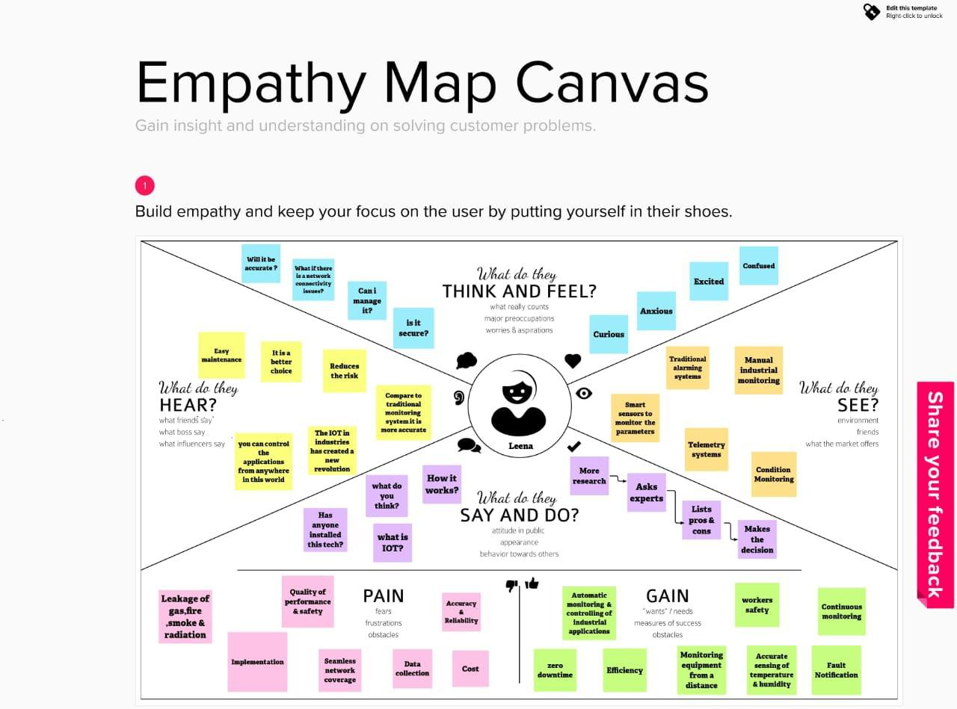

**b. Ideation & Brainstorming**

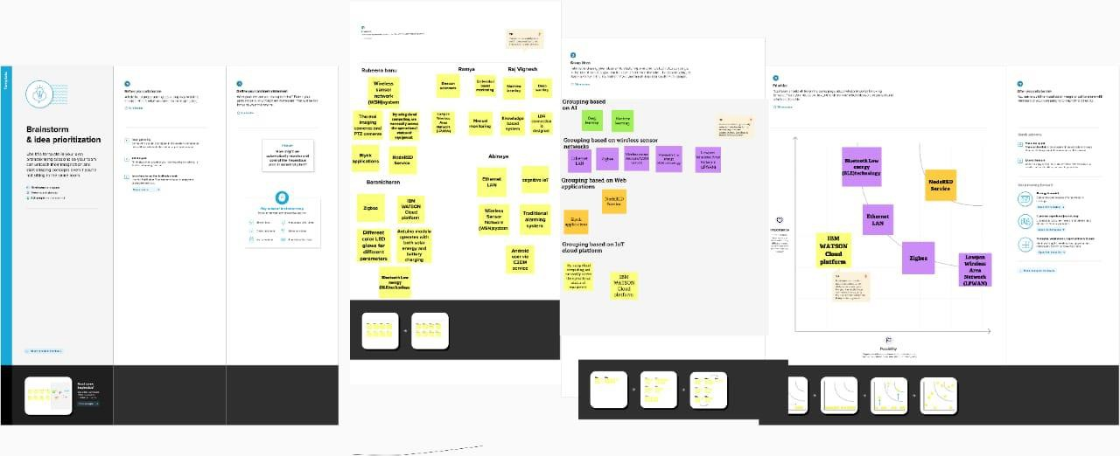

6

**c. Proposed Solution**

(a) Problem statement:

Hazardous area monitoring for industrial plants powered by IoT.(b) Idea /solution description:

➢ Beacon scanners for temperature indication.

➢ Receive Alerts to the mobile through email.(c) Novelty/ Uniqueness:

Bluetooth low energy module in IoT.

(d) Social impact / customers satisfaction:

➢ Continuous monitoring of Industrial Hazardous area.

➢ Reliable communication between workers and Fixed base stations.(e) Business model (Financial Benefit):

➢ Low power consumption

➢ Cost effective

➢ Easy portable

➢ Handy

(f) Scalability of solution:Scalable

**d. Problem Solution fit**

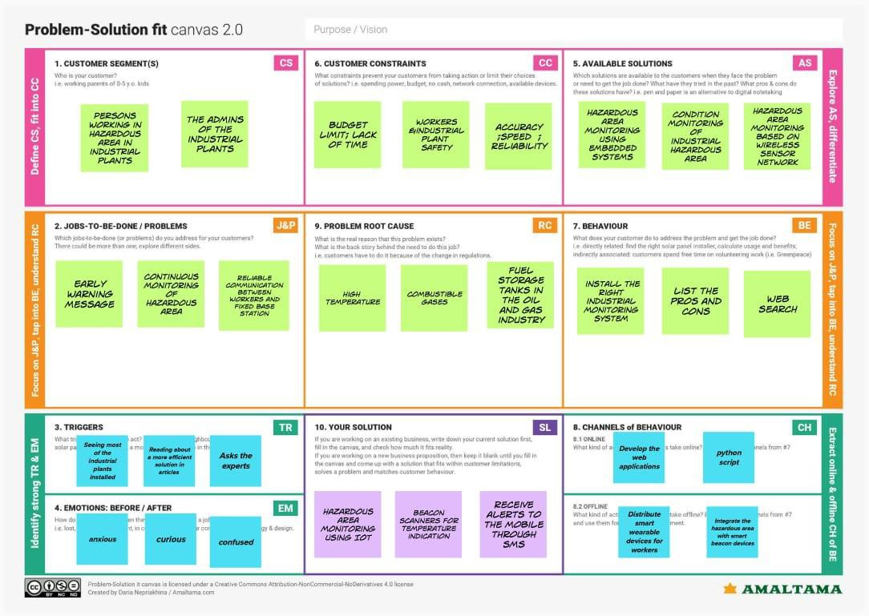

7

**4.REQUIREMENT ANALYSIS**

**a. Functional Requirements**

Following are the functional requirements of the proposed solution

**FR No. Functional Requirement (Epic) Sub Requirement (Story / Sub-Task)**

FR-1 User Registration ➢ Registration through Form

➢ Registration through Gmail

➢ Registration through LinkedIn

FR-2 User Confirmation ➢ Confirmation via Email

➢ Confirmation via OTP

FR-3 Monitoring ➢ To monitor the condition ofarea

➢ To monitor the temperature

and humidity

➢ To monitor these places theworkers will be given a smartdevice which will act as abeacon scanner.

FR-4 Remote Temperature monitoring ➢ Using LM35 Sensor and

Intimate

➢ Using DHT22 Sensor and

Intimate

FR-5 Module ➢ Arduino module is displayedin(16x2LCD)

➢ Analog to digital (ADC)converter is used to measurethe Voltage and current.

➢ LED glow when there is somegas leak

➢ Alert message through email

8

**b. Non-Functional Requirements**

Following are the non-functional requirements of the proposed solution.

**NFR No. Non-Functional Requirement Description**

NFR-1 **Usability** Area monitoring is a great tool that canbe used to see whether temperaturehazards are on your place.

NFR-2 **Security** More secure and receive alert to themobile through email.

NFR-3 **Reliability** Reliable communication betweenworkers and fixed base station.

NFR-4 **Performance** Model will achieve high accuracy withgood potential.

NFR-5 **Availability** Hazardous area monitoring using

Embedded system and WSN.NFR-6 **Scalability** Scalable

**5.PROJECT DESIGN**

**a. Data Flow Diagrams**

A Data Flow Diagram (DFD) is a traditional visual representation of the information flowswithin a system. A neat and clear DFD can depict the right amount of the system requirementgraphically. It shows how data enters and leaves the system, what changes the information, andwhere data is stored.

9

**DFD for hazardous area monitoring of industrial power plant powered by IoT:**

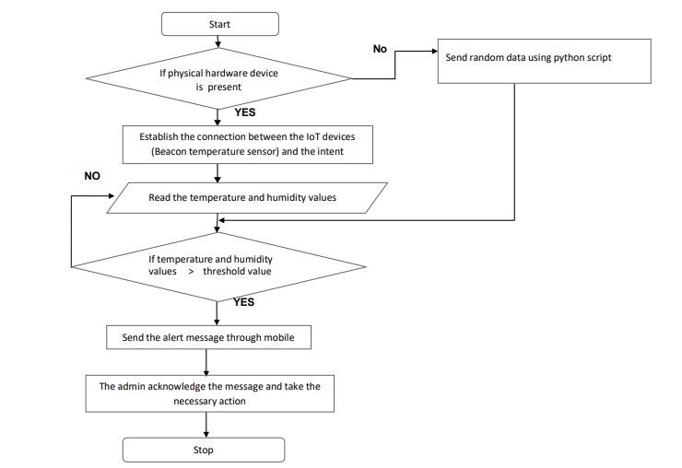

**b. Solution & Technical Architecture**

**Technical Architecture**

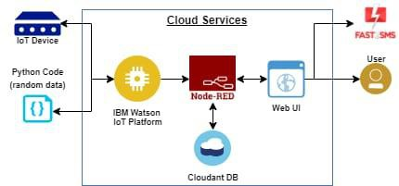

10

**Solution architecture**

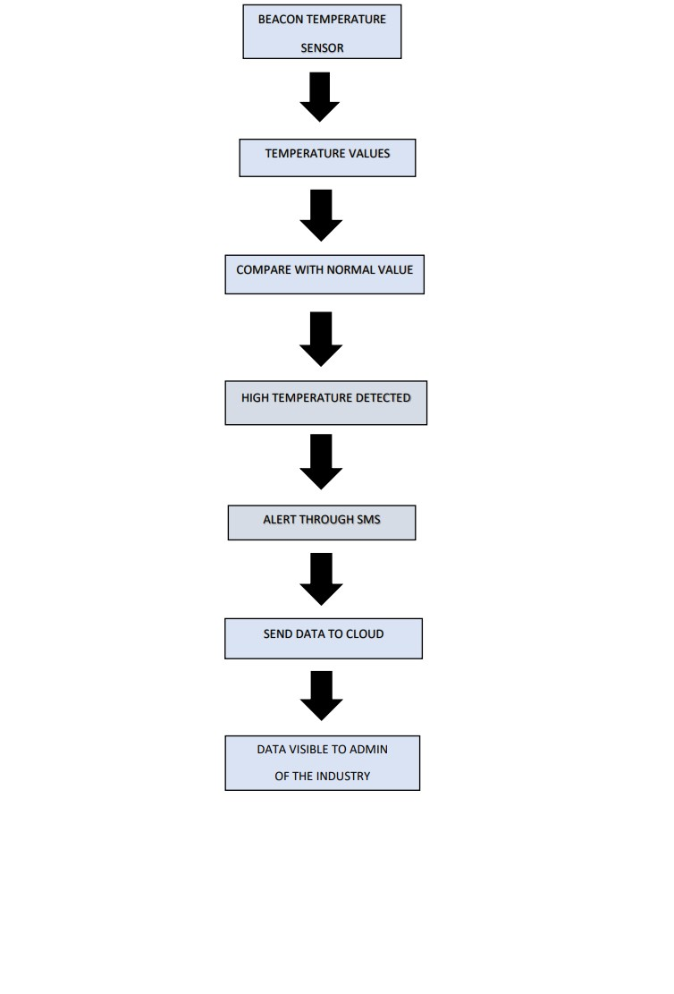

11

**c. User Stories**

**User Type FunctionalRequirement(Epic)**

**User Story**

**Number**

**User Story /Task**

**Acceptancecriteria**

**Priority Release**

Customer(admins oftheindustrialpowerplants)

Installation USN-1 As a user, I caninstall IoTdevices such asbeacontemperaturesensor.

USN-2 As a user, I cansend thepython script(random data)to the IoTplatform.

USN-3 As a user, I canreceive SMSusing API.

USN-4 As a user, I candownload thewebapplication.

Login USN-5 As a user, I canlogin to theapplication byemail andpassword.

I can view thetemperature ofthe hazardousarea

I can receivethe alertsthroughmobile.

High Sprint-1

High Sprint-1

High Sprint-2

Medium Sprint-1

High Sprint-1

Customer(Workers inthehazardousarea)

Dashboard

Database USN-6 As a user, I canstore all thedata in the IBMcloud

database.

12

13

**6.PROJECT PLANNING & SCHEDULING**

**a. Sprint Planning & Estimation**

**Sprint FunctionalRequirement(Epic)**

**Versions UserStoryNumber**

**User Story /Task**

**Reporter Storypoints**

**Priority**

Sprint-1 Installation Version 1 USN-1 As a user, Imust installthe IoT device

simulators (i..equick emulatorfor raspberrypi.

Sprint-1 USN-2 As a user, I canconfigure theQuick

Emulator

(qemu).

Sprint-1 Coding Version 1 USN-3 I can writecode togeneraterandomtemperatureand humidityvalues.

Nithyasri D.C

Nithyasri D.C

Naveena R

5 High

5 Low

5 Medium

Sprint-1 Debugging Version 1 USN-4 I can debugand rewritethe code ifthere is anerror.

Naveena R 5 Medium

Sprint-2 Owner Version 1 USN-5 As a user, Imust buy thecloudantdatabase.

Sprint-2 Login Version 1 USN-6 As a user, I canlogin to theIBM WatsonIoT platformwith the help

of usernameand password.

Swathi B

Swathi B

5 High

5 High

Sprint-2 Connection Version 1 USN-7 I can connectthe devices tothe IBMWatson IoTplatform.

Vaishnavi S 5 High

Sprint-2 Installation Version 2 USN-8 I can installand place thenodes onNode-RED.

Vaishnavi S 5 Medium

Sprint-3 Node-RED Version 2 USN-9 As a user, I canview the datain Node-RED.

Vaishnavi S

5 Medium

Sprint-3 APP

developing

Version 2 USN-10 I can developwebapplications.

Naveena R

5 High

Sprint-3 Downloading Version 2 USN-11 As a user, I candownload thewebapplication.

Sprint-3 Login Version 2 USN-12 As a user, I canlogin to thewebapplications.

Nithyasri DC 5 High

Swathi B 5 High

Sprint-4 Admin Version 2 USN-13 As a user, I canview thetemperatureand humidityvalues.

Vaishnavi S

10 Medium

Sprint-4 Version 2 USN-14 As a user, I canreceive alertmessages.

Naveena R 10 High

**b. Sprint Delivery Schedule**

**Sprint Total Story**

**Points**

**Duration Sprint Start**

**Date**

**Sprint EndDate(Planned)**

**Story PointsCompleted (ason Planned EndDate)**

**SprintRelease Date(Actual)**

Sprint-

1

Sprint-

2

Sprint-

3

Sprint-

4

20 4 Days 01 NOV 2022 04 NOV 2022 20 01 NOV 2022

20 4 Days 05 NOV 2022 08 NOV 2022

20 4 Days 09 NOV 2022 12 NOV 2022

20 4 Days 13 NOV 2022 16 NOV 2022

14

**c. Reports from JIRA**

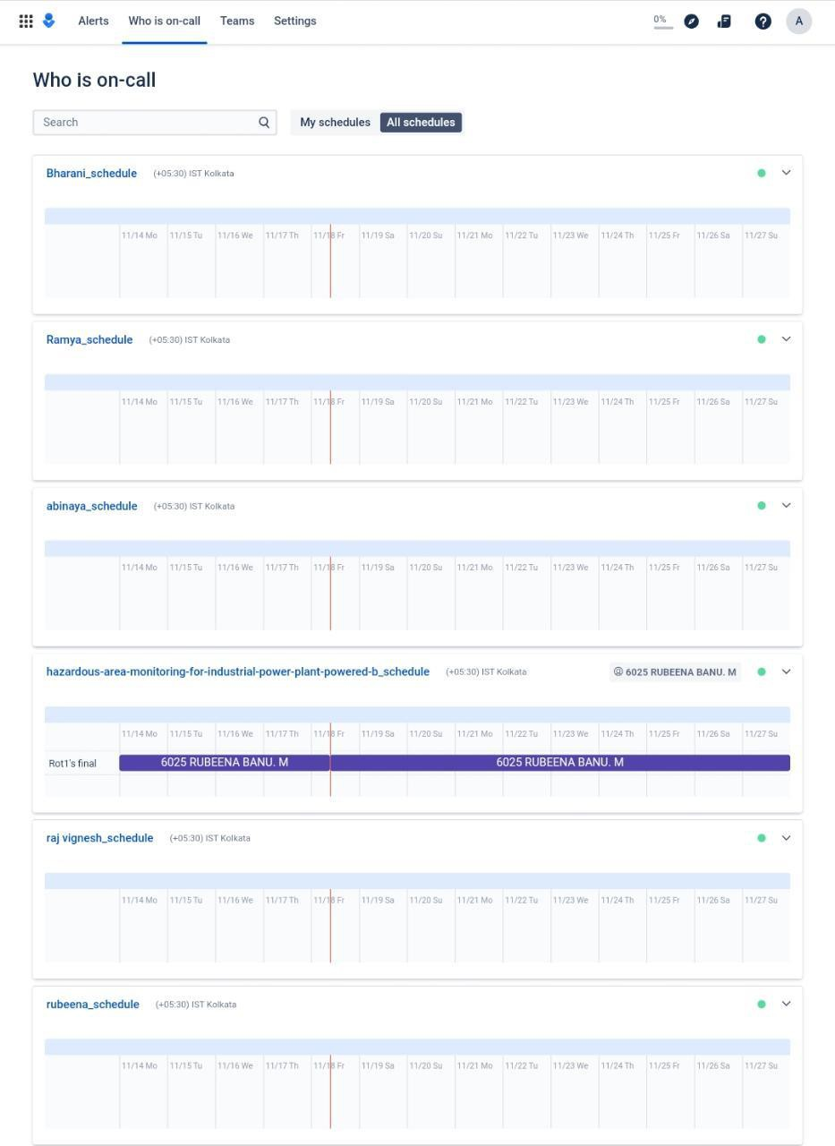

**7. CODING & SOLUTION**

Language: Python.

Tools/IDLE: Python 3.9.6, IBM Watson IoT platform, Node-RED, Email,Cloudant DB.

15

**#connecting the python to IBM watson IoT platform**

import wiotp.sdk.deviceimport time

import randommyconfig = {

"identity":{"orgId":"zvvqaf","typeId":"IoT_devices","deviceId":"12345"

},"auth":{

"token":"qagOTm?(qV+deBQ*j*"

}

}

def myCommandCallback(cmd):

print("Message received from IBM IoT platform: %s" % cmd.data['command'])

m=cmd.data['command']

client = wiotp.sdk.device.DeviceClient(config=myconfig, logHandlers=None)

client.connect()

16

while True:

temp=random.randint(-20,125)hum=random.randint(0,100)myData={'temperature':temp, 'humidity':hum}

client.publishEvent(eventId="status", msgFormat="json",data=myData,qos=0,onPublish=None)

print("Published data Successfully: %s",myData)client.commandCallback =myCommandCallbacktime.sleep(2)

client.disconnect()

**8.TESTING**

**a. Test Cases**

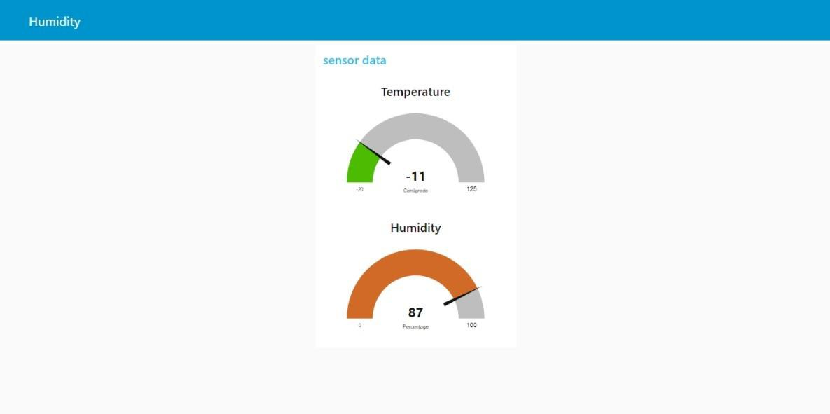

17

**b. User Acceptance Testing**

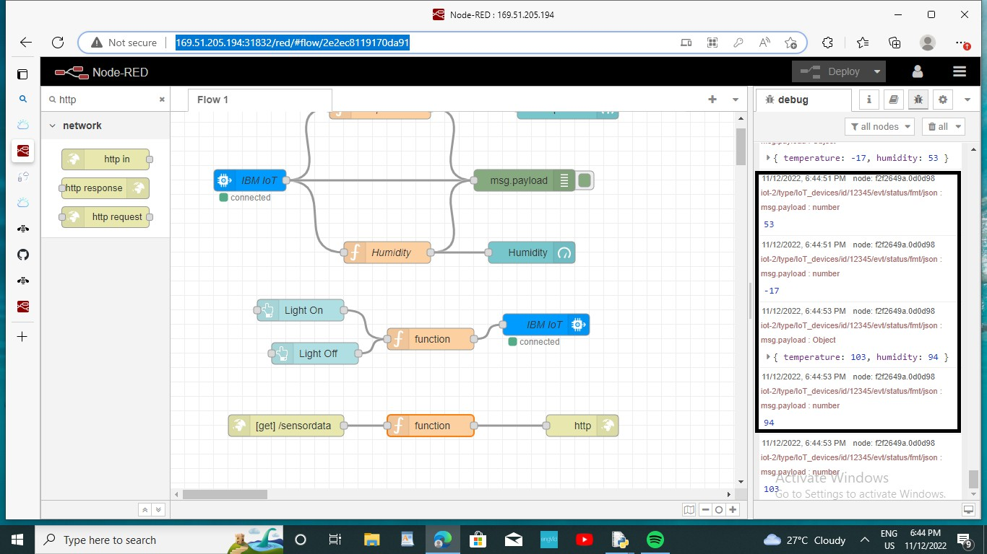

**Fig. Screenshot of node-RED connections**

**9.RESULTS**

**a. Performance Metrics**

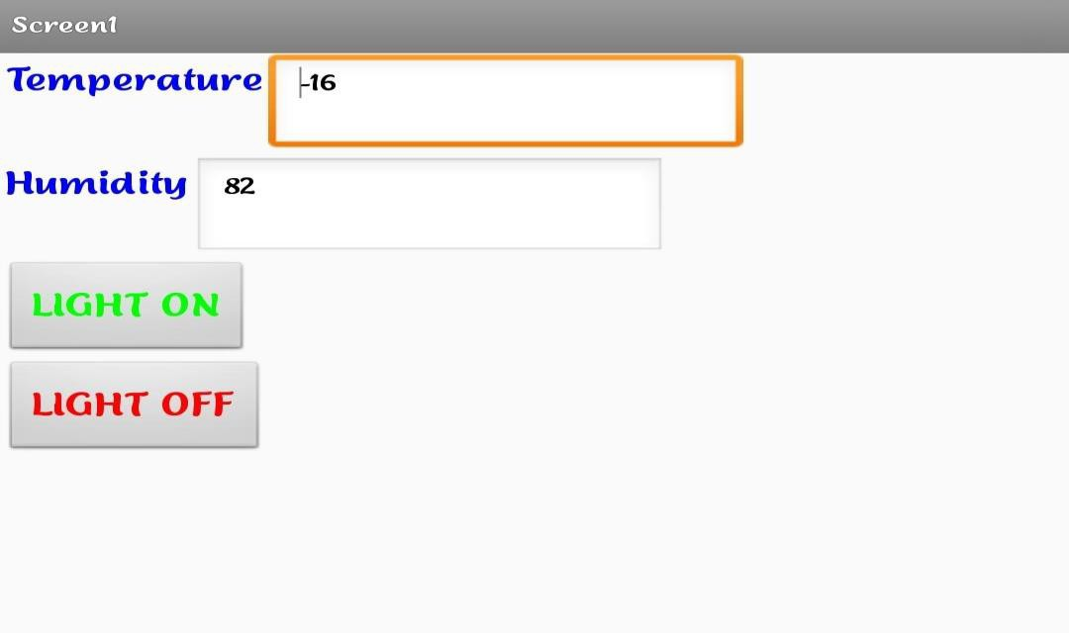

**Fig. Screenshot of mobile application**

18

**10.ADVANTAGES & DISADVANTAGESADVANTAGES**

• Quickly Finding Any Issue in Production Line.

• Keeping Records of Raw Materials & Accuracy.

• Predict what problem might occur.

• Decrease the deaths in Accidents.

• Ensuring safety and comfort.

• No Need for Routine Survey.

**DISADVANTAGES**

• Misuse of privacy and data.

• Expense.

• Communication channel disconnection occurs often.

• Complex uses.

**11.CONCLUSION**

The Internet of Things has a broad perspective in shaping tomorrow’s world. Even thoughthe IoT system has some demerits, its merits like saving consumer’s time and money outstand itscons. It is predicted that soon IoT applications will be installed and used equally in both domesticand industrial areas. Companies are working hard to shoot back IoT disadvantages and makingthis futuristic technology more beneficial for the betterment of humanity.

**12.FUTURE SCOPE**

IoT is bound to be an effective technology in the future, and IoT enabled devices are likely to beall-pervasive, from industry to households. The future scope of IoT is bright and varied, and it isonly a matter of time before the above applications of the technology are realized.

While wearable technology allows patients to self-monitor their health in real-time, the sensorsand variants used in the healthcare industry are significantly more sophisticated. As sensors’accuracy and precision based on IoT increases, the share of manual errors in taking medicalreadings will decrease.

19

**13.APPENDIX**

**a. Source code**

#connecting the python to IBM watson IoT platformimport wiotp.sdk.device

import timeimport randommyconfig = {

"identity":{"orgId":"zvvqaf","typeId":"IoT_devices","deviceId":"12345"

},"auth":{

"token":"qagOTm?(qV+deBQ*j*"

}

}

def myCommandCallback(cmd):

print("Message received from IBM IoT platform: %s" % cmd.data['command'])

m=cmd.data['command']

client = wiotp.sdk.device.DeviceClient(config=myconfig, logHandlers=None)

client.connect()

20

while True:

temp=random.randint(-20,125)hum=random.randint(0,100)myData={'temperature':temp, 'humidity':hum}

client.publishEvent(eventId="status",msgFormat="json",data=myData,qos=0,onPublish=None)

print("Published data Successfully: %s",myData)client.commandCallback =myCommandCallbacktime.sleep(2)

client.disconnect()

21